Katharine Young
Case Study
Fall 2015

Section 1 Contextual Factors
- Description of school context
I am student teaching in a kindergarten classroom in a suburban school district. The district contains six public elementary schools, one middle school, and one high school. This building is fifty years old and was built in 1965. The school offers a variety of support services: counseling, special education, English Language Learners (in all grades), speech language pathologist, high ability learners, preschool program, before and after school care, social work services, health services and more. According to their website for the 2014-2015 year, the school has 385 students in preschool through sixth grade. 72% are on the free and reduced lunch program. The ethnicity data year of 2014-2015 is 60% Caucasian, 27% Hispanic, 7% African American, 2% Asian, and 4% other. The English Language Learner percentage of the whole district is 6% with 31 languages spoken. Our class is 50% Hispanic, 40% Caucasian, and 10% Middle Eastern.
- Description of class context
There are twenty one students in the kindergarten class. This includes ten boys and ten girls. There are eight English Language Learners who get pulled out for assistance with language skills and understanding the English Language. The class has two Middle Eastern students, ten Hispanic students, seven Caucasian students, and one Asian student. Two students live out of the district and take the bus to come to school. Once Intervention and Enrichment (I & E) starts, the para will take students out for time in the resource room.

Student # | Developmental Data | Learning Style | Interests | Objective Anecdotal Notes
3 | Speech Language Impairment | This student is a visual and hands on learner. | This student loves tigers and likes to laugh. | This student does well in small groups working one on one with the teacher.

- Implications these factors may have on instructional planning
Given the high number of English Language Learners in our classroom the teacher and I believe that small groups and one on one instruction will benefit the class the most. I will direct lessons with students in small group rotations. Before and after the reading unit I will do a pre and post test to see if they acquired the learning target. During intervention and enrichment time, the teacher has centers laid out for the students to work on at their own pace. This time resembles daily five in that the rotations include a listening, writing, and reading center.
Section 2 Learning Goals/Outcomes
- Description of and background of learning goals selected
Within this unit the students are supposed to be learning sight words. This is where the most need is. Sight words are an integral part in reading. These are the words children need to know because they are the most frequently used in reading. In each lesson they will review past sight words before they learn a new one. They will also learn how to use their reader finger to help them read. In the groups of below level children they will build phrases and those higher level children will have simple phrases.
LA 0.1.1.f Demonstrate knowledge that print reads from left to right and top to bottom.
  - I can use my reader finger and slide it under each word as I read from left to right.
LA 0.1.1.c Demonstrate) voice to print match (e.g., student points to
print as someone reads)
  - I can use my reader finger and slide it under each sight word as I read.
LA 0.1.3.c Read at least 25 basic high frequency words from a commonly used list
  - I can read the word I, a, my, and the.
  - I can build a sight word tower.
LA 0.1.5.c Develop awareness of context clues (e.g., predictions, word and sentence clues) and text features (e.g., titles, bold print, illustrations) that may be used to infer the meaning of unknown words
  - I will use the pictures in the book to help me read the words I do not know.
LA 0.2.1.b Apply prewriting activities to generate ideas (e.g., brainstorming, discussions, drawing, literature, personal/classroom experiences)
  - I will discuss with my classmates a simple phrase using a sight word.
LA 0.2.1.c Generate representations of ideas (e.g., pictures, labels, letter strings, words, simple sentences); select and organize ideas relevant to a topic
  - I will be able to use pictures around my classroom to create sentences with my sight words.
LA 0.2.2.a Write for a specific purpose (e.g., lists, alphabet book, story with picture, label objects in classroom)
  - I will draw a picture to build a phrase with my sight word.
Section 3 Description of Assessment Plan
- Describe what and how you will assess
Skills will be assessed through performance: were students able to do the objective. The teacher will check each student’s work after the lesson.
- Differentiation for individual needs
The work will be adapted to best fit the level of each child. Those who are struggling will have extra review on troublesome sight words. Repetition is key. On those students who are below level we will work on building phrases with their sight words. There will be a notecard with the sight word written on along with action pictures. The children will build and read their phrases like “I slide.” On those higher level students we will work on simple phrases. Instead of I and an action picture, the sentence will include more sight words like “I see a…”
Summary Chart of Assessment Goals
Learning Goal | Assessment | Assessment Format | Differentiations Including Modifications/Accommodations
Objective # 1  I can use my reader finger and slide it under each word as I read from left to right. | Pre-assessment | Pre-test- Ask students if they know what a reader finger is. | Whole group discussion.
 | Formative Assessment | Listen to students reading | The teacher can read out loud as student follows with finger.
 | Summative Assessment | Performance- were students able to read left to right? | Whole group/circle activity. The teacher walks around and observes students.
Objective # 2  I can use my reader finger and slide it under each sight word that is read by the teacher. | Pre-assessment | Pre-test- Ask students to use their finger and slide as they read. | Whole group discussion. Demonstrate how you use your reader finger.
 | Formative Assessment | Listen to students reading. | The teacher can read out loud as student follows with finger.
 | Summative | Performance- Were students able to use reader finger and slide under word they read. | Whole group/circle activity. The teacher walks around and observes students.
Objective # 3  I can read the word I, a, my, and the.  I can build a sight word tower. | Pre-assessment | Pre-test to determine which sight words they know. | If a student is struggling with these words- stay and work only on these until they get them.
 | Formative Assessment | Students will look through a book to find their sight word.  Students will also play rainbow roll to read and write sight words. | Small group activity.
 | Summative Assessment | Performance- Students will have a pre-decodable reader book to highlight the sight words I, a, my, and the. Did they highlight the correct words?  Students will get to build a tower. They name the sight word (taped on tower) If they can read correctly they keep the tower. This is to see how many words they know and how tall their tower is. | Students who struggle with will highlight one sight word instead of four.
Objective # 4  I will use the pictures in the book to help me read the words I do not know. | Pre-assessment | Ask students what they do when they come onto a word they do not know. | Whole group discussion.
 | Formative Assessment | The student will describe what is in the picture out loud. | Small group activity.
 | Summative Assessment | Performance- Did the students look at the pictures in the book? | Small group activity.
Objective # 5  I will discuss with my classmates a simple phrase using a sight word. | Pre-assessment | The teacher will give an example, “I slide” and ask the class for examples too. | Whole group discussion.
 | Formative Assessment | Did each student give an example to their classmate? | One on one with a friend. On those students who struggle talking to others, have them turn to you (teacher) and talk.
 | Summative Assessment | Ask all students one by one to give the phrase they used with their classmate. | Whole group activity.
Objective # 6  I will be able to use pictures around my classroom to create sentences with my sight words. | Pre-assessment | Ask students to look around the room for ideas to use in a sentence. | Whole group activity.
 | Formative Assessment | Monitor small groups looking around the room and creating sentences. | Work in small groups.
 | Summative Assessment | Performance- with their sight words the students will draw the picture they found around the room to build their phrase. “My horse.” | Small group activity. The teacher will walk around the room and observe.
Objective # 7  I will draw a picture to build a phrase with my sight word. | Pre-assessment | Discuss different pictures to include with all the sight words we know into a phrase. | Whole group activity.
 | Formative Assessment | Monitor small groups creating their phrases. | Work in small groups. Pair higher learners with those who struggle.
 | Summative Assessment | The students will write a sight word and create a picture to finish their phrase like “I run.” They will write I and then draw a picture of them running. | Small group activity. The teacher will walk around the room and observe.

Section 4 Design for Instruction

College of Saint Mary
Lesson Plan Maker Variation for Early Childhood Education
LESSON/ACTIVITY INFORMATION
Title: Rainbow Roll
Your name:  Katharine Young | Age or Grade Level:  Kindergarten |  | Integrated Disciplines/Subjects:  Guided Reading | Time frame for Lesson:  15 min.
STANDARDS, OBJECTIVES, ASSESSMENTS & MATERIALS
Nebraska State Standards:
LA 0.1.3.c Read at least 25 basic high frequency words from a commonly used list

Objectives: The students will be able to play rainbow roll in order to read and write sight words in fun colors.

Assessment: The teacher will check student work to see if they could write their sight words.

Materials:
* Rainbow writing card
*Sheets of paper
*Colored Makers
* Dice

LESSON PROCEDURES
Anticipatory Set: We have a fun activity today. In order to help us learn our sight words we are going to practice writing them in fun colors! Here we have rainbow writing. Let’s review our sight words. What is this one? I, a, the, my.

Teacher will do:  - Introduce the activity and explain the rules.  - The teacher will pick sight words that the student needs to work on the most and write them on the board for them to look at.  - Each student will get a small dice. The teacher will go over how we correctly roll the dice.  - When the dice stops we count the number it lands on. We then look on the rainbow writing sheet to find that number and look for what color we write in.  - So if you land on five you will write the sight word from your in blue.  - You will write as many sight words till the chime rings.  - Afterward I will look over your paper and ask you to read the sight words you wrote down. |  | Student will do:  - The students will listen to the teacher’s directions.  - They will participate in each activity by following directions.  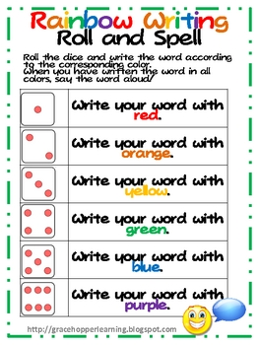
Closure: What sight words did you write down? Point to each one and have them recite back. When you rolled your dice, what color did you come up with the most?
Differentiation: On those who are struggling with learning sight words the teacher can write the sight words on top of their paper so they can easily see and follow.

Higher level learners the teacher can add on more sight words.

References: * Mrs. Lehan

LESSON ANALYSIS
Review all of the previous sections of your lesson plan and
complete item in the following section prior to teaching your lesson.
Content Knowledge:
This lesson addresses the necessity to learn and quickly read sight words. Sight words are essential to the start of reading.

Teaching Methods/Strategies:
The teaching method used for this lesson is small group activity and discussion.

REFLECTION
After teaching the lesson, write a reflection to evaluate how you feel the lesson went (flow, timing, materials, etc.) and write a clear description about evidence of student learning. This description should directly refer to your plans for Assessment including your documentation strategies.

This lesson was tricky for a few of the lower level students. This is when I started writing the sight words they are working on, on their actual paper so it was easier for them to see and know the words they write. Once I did this they started enjoying the activity more. I noticed the movement of rolling the dice was fun for them and the choosing of the different colors.

Modified by Dr. M. K. Felton
October 3, 2013

College of Saint Mary
Lesson Plan Maker Variation for Early Childhood Education
LESSON/ACTIVITY INFORMATION
Title: Sight word sentences.
Your name:  Katharine Young | Age or Grade Level:  Kindergarten |  | Integrated Disciplines/Subjects:  Guided Reading | Time frame for Lesson:  25 min.
STANDARDS, OBJECTIVES, ASSESSMENTS & MATERIALS
Nebraska State Standards:
LA 0.1.1.c Demonstrate) voice to print match (e.g., student points to print as someone reads)
LA 0.1.3.c Read at least 25 basic high frequency words from a commonly used list
LA 0.2.1.c Generate representations of ideas (e.g., pictures, labels, letter strings, words, simple sentences); select and organize ideas relevant to a topic
LA 0.1.1.f Demonstrate knowledge that print reads from left to right and top to bottom.

Objectives: The students will be able to choose an action picture to follow a sight word in order to create their simple sentence.

The students will be able to read their sentence using their reader finger.

Assessment: The teacher will listen to students read.

Materials:
* Simple action pictures like (slide)
*Sight word cards

LESSON PROCEDURES
Anticipatory Set: We are becoming readers! Today we are working on the sight words a, and I.
What does this picture show? Yes, run! Now we are going to put these two together to create a sentence. I run. Show me your reader finger. It is your first finger. As we read we slide our finger under the word we are reading. Ask kids to come up and demonstrate.

Teacher will do:  - Demonstrate how to use your reader finger. We start from left to right. Does my finger hop to each word? “No.” We slide it.  - Ask students to turn to a friend. Knee to knee. Have them use I, and A in a sentence.  - Give them 1-2 minutes to discuss. Give them a signal to turn back to you. “1, 2, 3 now back to me.”  - Call on individual students to tell everyone what sentence they created.  - Our next sight words are my and the. Practice whole group creating sentences. My dog. My mom. My heart. The cricket. The banana.  - Ask students to turn to a friend. Knee to knee. Have them share with their friend a sentence with my and the.  - Give them 1-2 minutes to discuss. Give them a signal to turn back to me. “1, 2, 3, back to me.”  - Call on individual students to share their sentence.  - Have students go back one by one to the tables and work on their sentence. Each student will have a picture of their choosing. (Run, slide, smile, laugh, etc).  - They will go back to their table. On their worksheet they will write the sight word I and glue their action picture next to. |  | Student will do:  - Students will find a partner to go knee to knee with.  - Students will think of a simple phrase and share with their friend.  - When they are called on in whole group the student will share out loud the sentence they created.  - Once both partner activities are done the students will go back to the tables to create their simple sentences by writing the sight word and gluing their action picture.
Closure: Walk around the room and check students work. Have students read their simple sentence with their reader finger.
Differentiation:
Those students who struggle talking to others can work with the teacher as a buddy.

Higher level learners can create a longer sentence. “I can slide.” Or “I see the horse.”

References: Mrs. Lehan

LESSON ANALYSIS
Review all of the previous sections of your lesson plan and
complete item in the following section prior to teaching your lesson.
Content Knowledge:
This lesson addresses the necessity to learn and quickly read sight words. Sight words are essential to the start of reading.

Teaching Methods/Strategies:
The teaching method used for this lesson is whole group discussion, partner work, and individual table work.

REFLECTION
After teaching the lesson, write a reflection to evaluate how you feel the lesson went (flow, timing, materials, etc.) and write a clear description about evidence of student learning. This description should directly refer to your plans for Assessment including your documentation strategies.

Some of the students were shy to share their ideas with their partner. So I would walk around and become a part of their group in order to get them participating easier. I noticed kids starting looking around the room for ideas to use in their sight word sentence. This helped me think of another lesson for them to do later on. Some students were ready for adding onto their sentence. On the back of their paper I had them create another sentence. I definitely need to go over more the use of our reader fingers. Most students need practice sliding slowly under the words, not above or on.

Modified by Dr. M. K. Felton
October 3, 2013

College of Saint Mary
Lesson Plan Maker Variation for Early Childhood Education
LESSON/ACTIVITY INFORMATION
Title: ‘My’ sentences
Your name:  Katharine Young | Age or Grade Level:  Kindergarten |  | Integrated Disciplines/Subjects:  Guided Reading | Time frame for Lesson:  25 min.
STANDARDS, OBJECTIVES, ASSESSMENTS & MATERIALS
Nebraska State Standards:

LA 0.1.1.c Demonstrate) voice to print match (e.g., student points to print as someone reads)
LA 0.1.3.c Read at least 25 basic high frequency words from a commonly used list
LA 0.2.1.c Generate representations of ideas (e.g., pictures, labels, letter strings, words, simple sentences); select and organize ideas relevant to a topic
LA 0.2.2.a Write for a specific purpose (e.g., lists, alphabet book, story with picture, label objects in classroom)

Objectives: The students will be able to use pictures around my classroom to draw and create a minimum of five sentences with the sight word my.

Assessment: The teacher will walk around the room and have students read their drawings/sentences.

Materials:
* Markers
* Paper

LESSON PROCEDURES
Anticipatory Set: Ask students to look around the room for ideas to use in a sentence. Do you see the alphabet pictures over there? For H we see a heart. In my sentence I will use my heart. What will you use?

Teacher will do:  - Start anticipatory Set  - Ask what other pictures could we use in our sight word phrase?  - “My banana, my ballerina, my tower, etc)”  - Send students one at a time with a piece of paper to their tables to create their sentences.  - Watch as students create their sentences to see if they look around the room for ideas.  - Walk around the room and ask them to read a sentence. |  | Student will do:  - Students will participate in whole group discussion.  - When they are directed to their table work seats they will create their sentences like my and their drawing of a cat.  - Students will read their sentence when teacher comes around.  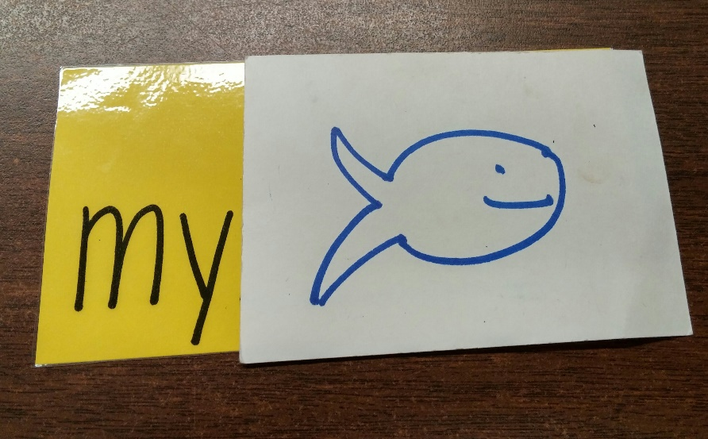
Closure: Walk around the room and ask them to read a sentence. Ask them which one is their favorite?

Differentiation:
Higher level learners can create more than five sentences.

Lower level learners can walk around the room to get an easier look at pictures.

References: Mrs. Lehan

LESSON ANALYSIS
Review all of the previous sections of your lesson plan and
complete item in the following section prior to teaching your lesson.
Content Knowledge:
This lesson addresses the necessity to learn and quickly read sight words. Sight words are essential to the start of reading.

Teaching Methods/Strategies:
The teaching method used for this lesson is whole group discussion and small group table work.

REFLECTION
After teaching the lesson, write a reflection to evaluate how you feel the lesson went (flow, timing, materials, etc.) and write a clear description about evidence of student learning. This description should directly refer to your plans for Assessment including your documentation strategies.

This was a fun way for the students to learn an important sight word and make it their own. They enjoyed finding their favorite pictures around the classroom for ideas. The students were discussing with their table mates what they were writing and drawing. It was fun to see.

Modified by Dr. M. K. Felton
October 3, 2013

College of Saint Mary
Lesson Plan Maker Variation for Early Childhood Education
LESSON/ACTIVITY INFORMATION
Title: Pre-decodable books/ Sight word towers
Your name:  Katharine Young | Age or Grade Level:  Kindergarten |  | Integrated Disciplines/Subjects:  Guided Reading | Time frame for Lesson:  20 min.
STANDARDS, OBJECTIVES, ASSESSMENTS & MATERIALS
Nebraska State Standards:
LA 0.1.3.c Read at least 25 basic high frequency words from a commonly used list
LA 0.2.1.c Generate representations of ideas (e.g., pictures, labels, letter strings, words, simple sentences); select and organize ideas relevant to a topic
LA 0.1.1.f Demonstrate knowledge that print reads from left to right and top to bottom.
LA 0.1.1.c Demonstrate) voice to print match (e.g., student points to print as someone reads)
LA 0.1.5.c Develop awareness of context clues (e.g., predictions, word and sentence clues) and text features (e.g., titles, bold print, illustrations) that may be used to infer the meaning of unknown words
Objectives: The students will be able to highlight the sight words I, a, my and the and look at the pictures in the book to help read aloud the words they do not know.
The students will build a sight word tower of Legos.

Assessment: The teacher will walk around the room and listen to those reading. The teacher will check to see if the correct words were highlighted. As they are reading, the teacher will see if they looked at pictures to help decipher what the word is.

The teacher will see how many words they know to build a tower.

Materials:
* pre-decodable books 1-4
* Lego’s with sight words taped on
* highlighter

LESSON PROCEDURES
Anticipatory Set: We are going to be little detective with our highlights. When we find a sight word we will highlight it. When we find them all we get to read our book! Once we finish we can build sight word towers that I’ll explain later

Teacher will do:  - Start anticipatory set.  - The teacher will hand out pre-decodable books and highlighters.  - The teacher will guide children to their tables.  - The teacher will walk around the room and watch children highlight their sight words.  - Once they are done I will listen to them read (watch for correct reader finger).  - When they finish have them sit in whole group spots.  - The teacher will give directions on sight word tower.  - Students will get to build a tower. They name the sight word (taped on tower) If they can read correctly they keep the tower. This is to see how many sight words they know.  - Students will be guided back to tables to work on these. |  | Student will do:  - Students will listen to the teacher’s directions. When they go back to their seats they will be detectives and high light sight words I, a, the, and my in their pre-decodable books.  - Once they are done they will wait quietly in whole group for others to finish.  - Students will listen to Lego tower directions.  - Students will then go back to seats and start building.  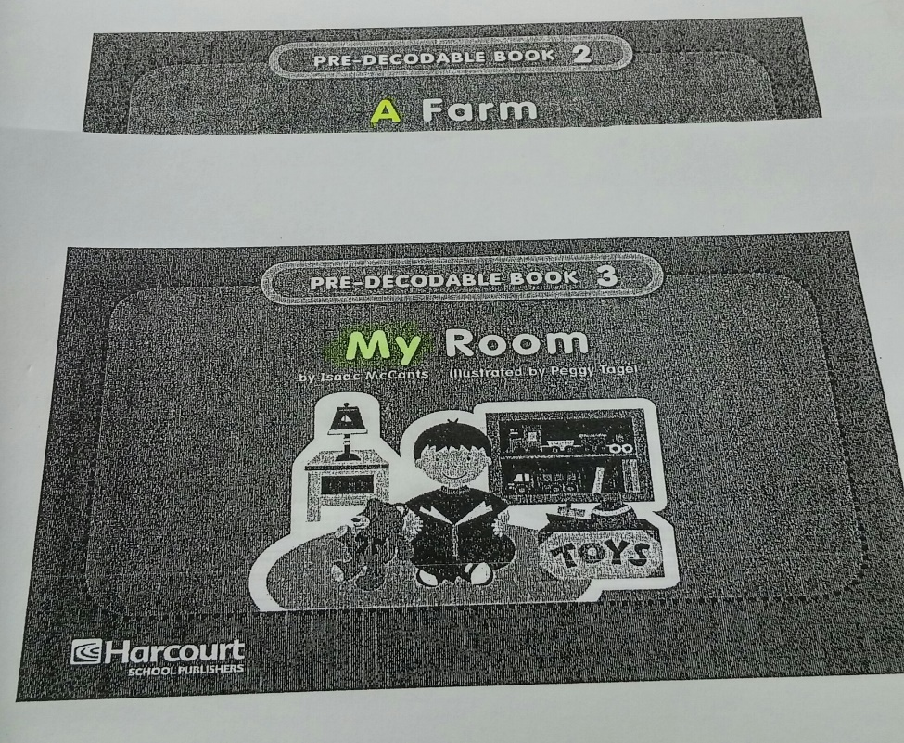
Closure: What words did we find?! How many Lego’s were you able to build?

Differentiation:

Students who are struggling will only highlight one sight word instead of all four.

Higher level learners can have more than one pre-decodable book to highlight.

References: Mrs. Lehan
LESSON ANALYSIS
Review all of the previous sections of your lesson plan and
complete item in the following section prior to teaching your lesson.
Content Knowledge:
This lesson addresses the necessity to learn and quickly read sight words. Sight words are essential to the start of reading.

Teaching Methods/Strategies:
The teaching method used for this lesson is small group activity and whole group discussion.

REFLECTION
After teaching the lesson, write a reflection to evaluate how you feel the lesson went (flow, timing, materials, etc.) and write a clear description about evidence of student learning. This description should directly refer to your plans for Assessment including your documentation strategies.

Next time I need to allot more time. Doing both activities requires more time. If I was just doing the highlighting the time would work out perfectly. The kids enjoyed the hands on of highlighting and building Lego’s. I think I will introduce less sight words for Lego’s or introduce this lesson later on. The kids who didn’t know as many words got frustrated with this easily because they couldn’t build much of a tower.

Modified by Dr. M. K. Felton
October 3, 2013

Section 5 Instructional Decision-Making
Adjustments Made to Lessons Based on Student Learning
All twenty students did not know what a reader finger was. When I read out loud and modeled with my reader finger going left to right, the students had no problem with it afterwards. This model included the sight word I and a picture of a student running. I would model my reader finger sliding left to right under each word. When I asked the students to use their finger and slide as they read these sight word sentence examples many wanted to cover up the words or use their reader finger where there were no words. We also had friends who hopped to each word instead of slide. The next day we discussed what a reader finger was again. The more practice we did helped the kids tremendously, especially on the predecodable books. On Rainbow Roll for those lower level students I noticed they had trouble looking at the guide in order to write their sight words. I had them gather around and we said out loud each of the sight words. Afterwords, I wrote the sight words on their individual papers that as a class we were working on. After this accommodation they were moving quickly through the lesson. On those higher level students, after the filled their worksheet full of sight words I gave a sentence using one of their sight words like, “I can see a clock.” I asked them to write a few sentences using their sight words they wrote in rainbow colors earlier. We also had differentiation on how many sight words the students were required to high light in their predecodable books. The activity the students enjoyed the most was the sight word building blocks and using a action picture for a sight word phrase. Adjustments made on the building blocks comprised of only putting out certain sight words that each group has worked on so far. I noticed if I put too many out the students would get frustrated.
Section 6 Analysis of Student Learning

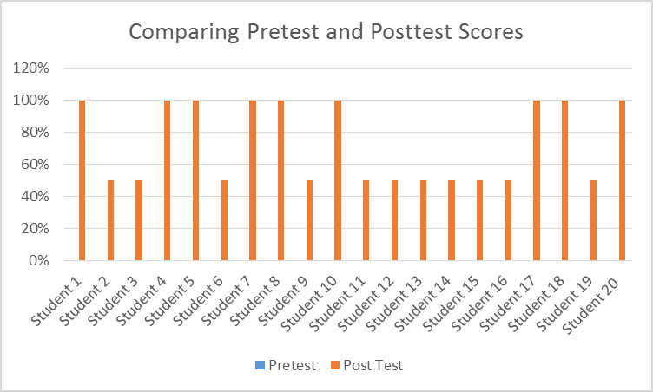
Written Analysis of Assessment Results

The pretest included asking the students a couple questions. They were:
- Do you know what a reader finger is?
- What do you do when you come onto a word you do not know?

As the graph shows all of the students did not know initially what a reader finger was or what you do when you get stuck on a word. The post test asked these same questions and on this test, nine out of Twenty or 45% of the students were able to correctly answer both questions. The 50% column were students who could answer #1 but couldn’t remember what to do on a word when we got stuck. So they got half the points. This information showed me where I needed to start with the students. We needed to start on the basics of reading. As we can see with review before lessons and lots of modeling almost half of my class improved in the basics of reading.

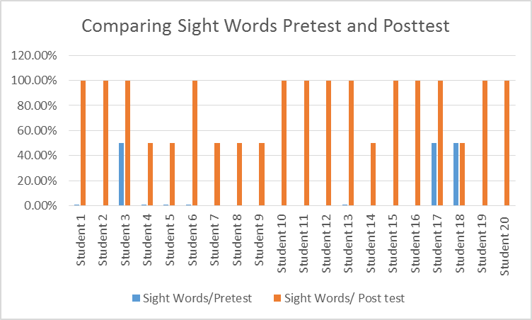

The pretest included asking the students if they knew the sight words I, a, the, and my. Many students as you can see in the graph did not know any of these sight words. A few knew at least two out of the four. The post test shows that thirteen out of twenty now know all the sight words while seven knew at least two. At least 65% of my class can identify their sight words compared to none before. I noticed the ‘a’ and ‘the’s’ get mixed up and so do the, I and my. This is most likely because they sound close to each other. These pretests showed me the students who needed the most work on reading with the correct reader finger and those who struggled the most on sight words.

Through our last activities of partnering with a classmate, using pictures around the classroom for ideas, and choosing a picture for a phrase I used a performance assessment checklist. This is where I checked off their names if they did the activity or not. I also walked around the room to observe and mark down more students who followed along. Did the students give an example to their classmates, did they offer one to the whole class, did the students draw the picture they found around the room to build their phrase, and did the students write a sight word and find a picture to finish their phrase like “I swim.” As we see in the chart above every student participated in each activity.

Section 7 Reflection and Self Evaluation

Overall, this was an eye opening experience. Many of our students are low leveled or English Language Learners. Many also have a hard time retaining information. This knowledge helped me designed my lessons to review old lessons quickly before we started new information. When I noticed a student was still not retaining the information I would switch some things around on my lesson in order to cater to their needs. Review was a theme with my lessons. As we see in the charts above, improvement was made in both reading knowledge and sight word identification. I noticed the reason for students not improving a significant amount are those who struggle with retention. Through these assessments, I had students with no prior knowledge of what a reader finger was and now up to 45% of the class does. I got 65% of my class identifying sight words when before only a few knew.
I believe what helped the students to make an improvement was from being in small groups. I was able to give each student one on one attention and show a connection to them through this interaction. The students have grown to trust and respect me. I think without the anxiety some kids feel in whole group, they really excelled. Small group is less intimidating. Since many of my assessments were through performance, small groups gave me the benefit of really seeing each student and what they could do.
Another benefit I feel was having interactive and fun activities like Rainbow Write and sight word blocks. I think these were effective too. They were having fun learning. They got to use their hands and roll the dice or build a sight word tower. I also like how they had the choice of a picture to describe them for our sight word sentences. This included their personalities. I found out who likes to run, laugh, and slide. If I were to teach this unit again I would definitely use these activities again. Next time I would separate the sight word blocks out. I would have each group, low level, on level, and above level have a basket of specific sight words for their group.
This study showed me that every student can learn. We celebrate the successes no matter how small. I also learned that for lower level students, repetition is key. I saw the benefit of small group interactions between me and the students and the students with each other. It was also fun to see the quiet students come out of their shell during these times. Another big insight was differentiation. When a student was struggling I would cut something out or add something. These small differences prevented frustrations and struggles.

